Helping your child with GCSE Maths

October 2019



Board: Edexcel

Exam dates: Tuesday 19th May (non-calculator),

Thursday 4th June (calculator),

Monday 8th June (calculator).

3 x 1hr 30 mins

Dear Parent/Carer

Studying for GCSE Maths is demanding for many students. Lots of hard work both in and out of school is required for students to be successful and for some students managing this and knowing where they can access support can be challenging enough even before they actually do the work.

This guide is designed to allow you to know some of the support avenues that are available so that you can assist your child in managing their out of schoolwork and revision over the GCSE years.

I hope you find this guide useful. If you require further support, then please contact your child’s maths teacher by email from the list below.

|  |  |
| --- | --- |
| Mr J Cunningham | j.cunningham@wollaston-school.net |
| Miss R Lynch | r.lynch@wollaston-school.net |
| Miss F Hester | f.hester@wollaston-school.net |
| Mrs V Dawes | v.dawes@wollaston-school.net |
| Ms S Hamblin | s.hamblin@wollaston-school.net |
| Mr E Fennell | e.fennell@wollaston-school.net |
| Mr C Rowland | c.rowland@wollaston-school.net |
| Mr S Gordon | s.gordon@wollaston-school.net |
| Mr E Stevenson | e.stevenson@wollaston-school.net |
| Mrs A Ayling | a.ayling@wollaston-school.net |

Yours faithfully

J Cunningham (Head of Mathematics and Computing)

R Lynch (Second in Mathematics Department)

**How to succeed in maths**

Success takes hard work but the effort will pay off. Students need to start early; there are over 300 topics. They need to make the most of every minute in class and **ask** if they don’t understand a topic. They should complete set homework and **seek support** if struggling. All teachers in the department are more than happy to sit with students to help. We also benefit from having two Higher Level Teaching Assistants who are happy to work with students.

When completing past papers or practice questions they should try to look up what they don’t know – use the websites that they know about or ‘Google’ it. There are many websites and videos on Youtube that demonstrate how to perform tasks and answer questions.

Revision can be as part of a **group** or **alone**. For example, using revision cards, completing past papers etc can be done with friends. Talking about approaches to questions will help. Working alone to complete past papers is useful so that students can evaluate where the gaps are for them. Having completed the past papers, using the mark scheme to find out what gets the marks is helpful. The workings are shown.

Rather than leaving gaps for answers, websites, revision cards and books can be used to look things up and learn key facts. There should be a focus on the topics that are less successful in mocks/practice papers.

It is essential that students are **equipped**. They should have a scientific calculator as well as compasses, protractor, ruler etc.

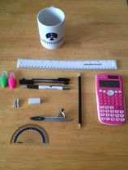

**Resources**

The Maths department subscribes to many different sites, and promotes many free sites that students can use to support their homework, revision or other independent learning. The subscription sites will require your child to have their personal log in details. They can get these directly from their teacher.

**Kerboodle**



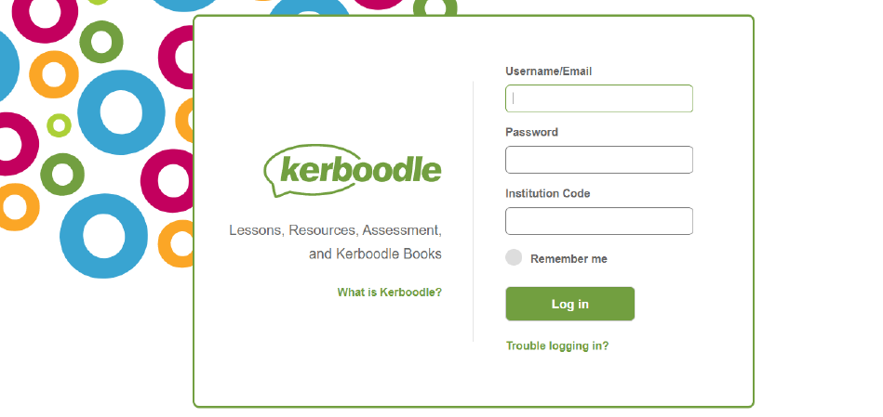

Your child’s username will normally be their first initial and surname (e.g. Joe Bloggs will be jbloggs). Occasionally, there will be a number after the username, particularly if there is more than one child in the school with the same first initial and surname. Your child’s teachher will be able to tell them their username if they are unsure.

The institution code for the school is fw4.

On Kerboodle your child can access a digital copy of the textbook, along with a digital copy of the linked homework book which can provide more questions for your child to practise.

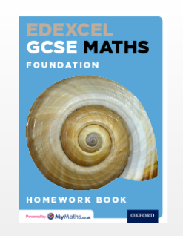 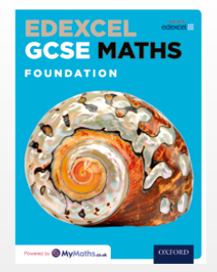 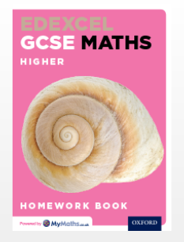 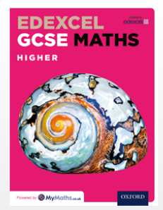

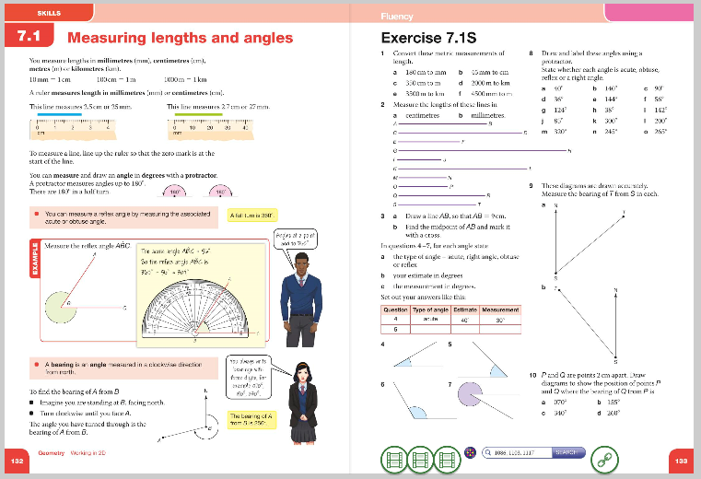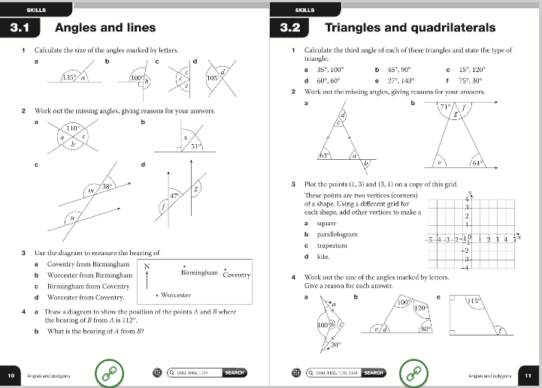

Each section of the text book has two links attached. The first is the ‘Invisipen’ video, which shows video examples of questions being performed on the topic selected. Your child can access the videos this button: 

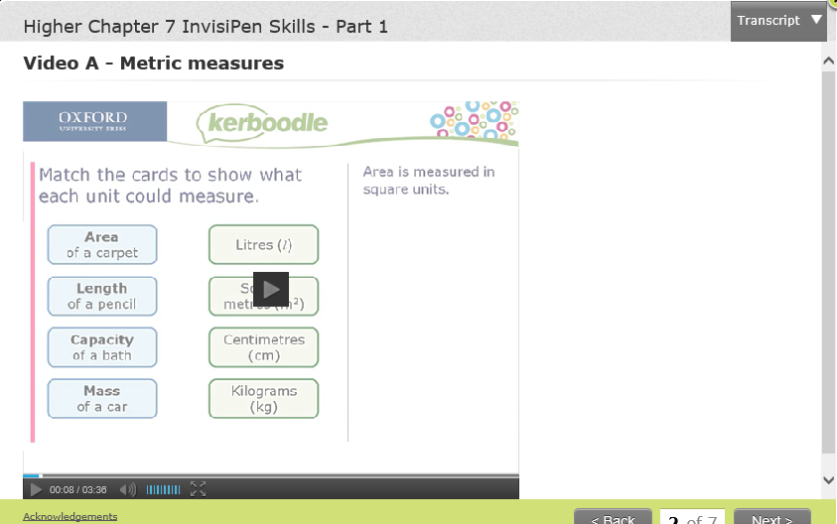

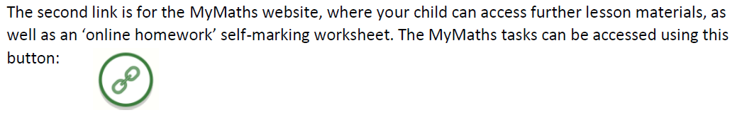

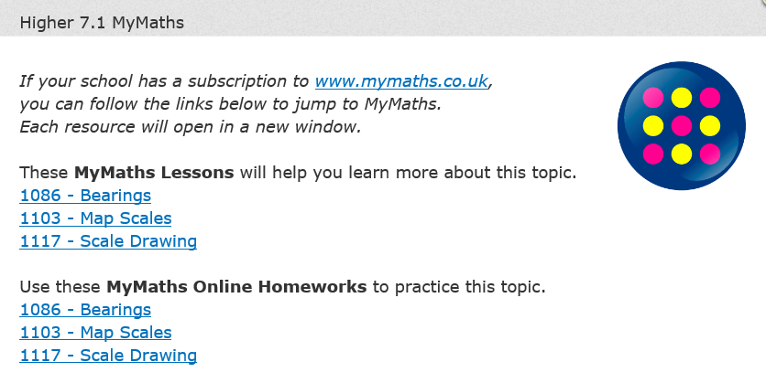

**Mymaths.co.uk**

*MyMaths (*https://www.mymaths.co.uk) – MyMaths is a website owned by Oxford University Press, the publisher of the textbook we use to support student learning in class. When accessing the website, either directly through web address or through the link on Kerboodle, students will need to log in using the school username and password. The username is ‘Wollaston’. The password usually changes each year; currently, it is ‘number’.

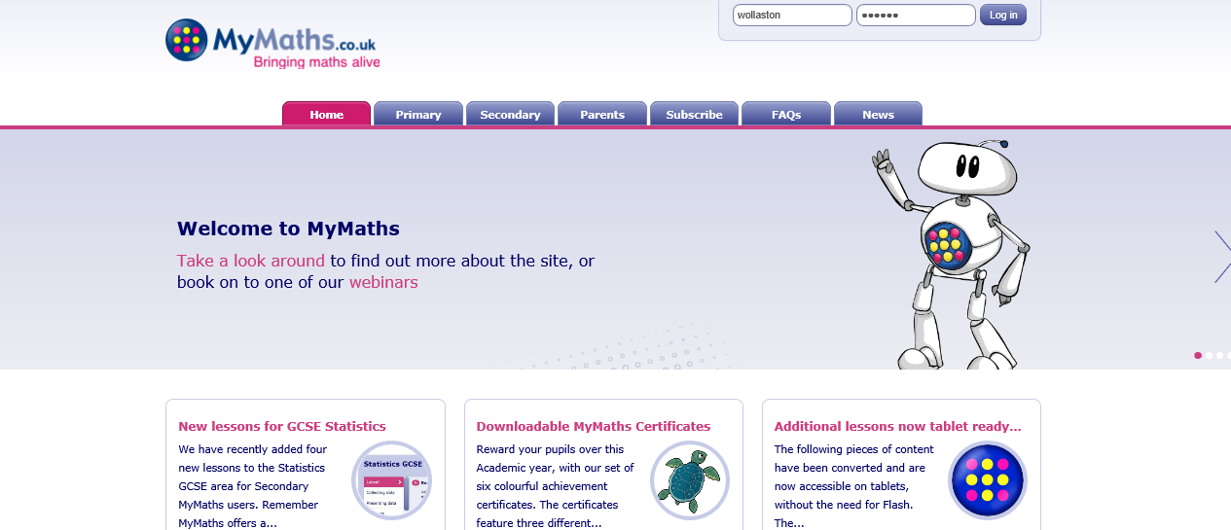

Once logged in your child will be able to access all areas of the site by browsing the library on the left hand side of the screen and selecting the appropriate section. However if your child needs to access specific tasks set by their teacher, or if your child wants the site to track their task attempts and results, then they will need to log in to their personal portal using their personal username and password.

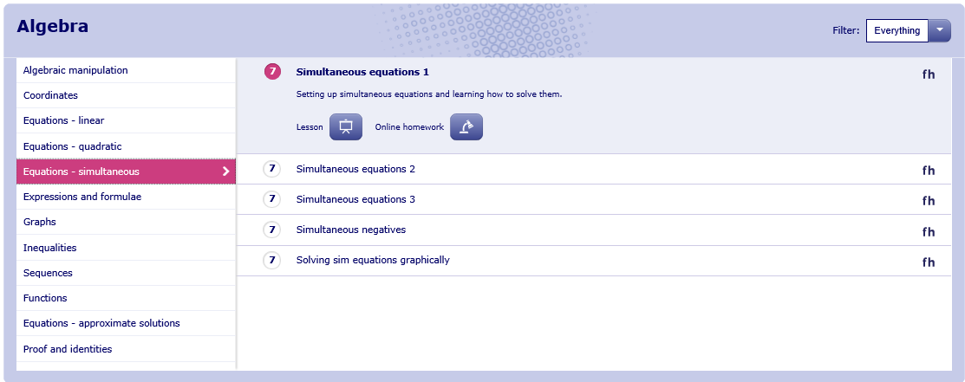

Their username is a four-digit number, and their password will be three random letters. Your child’s teacher will be able to tell your child their portal details if they do not know them.

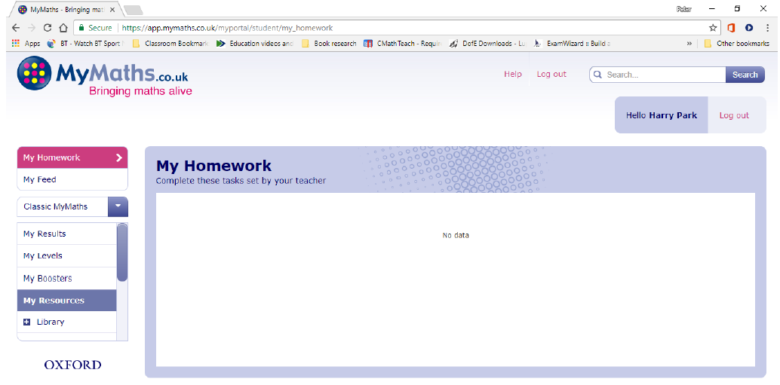

Once your child has logged into their portal, any ‘Online homework’ tasks attempted will have their score saved so that weaker areas can be tracked and reviewed.

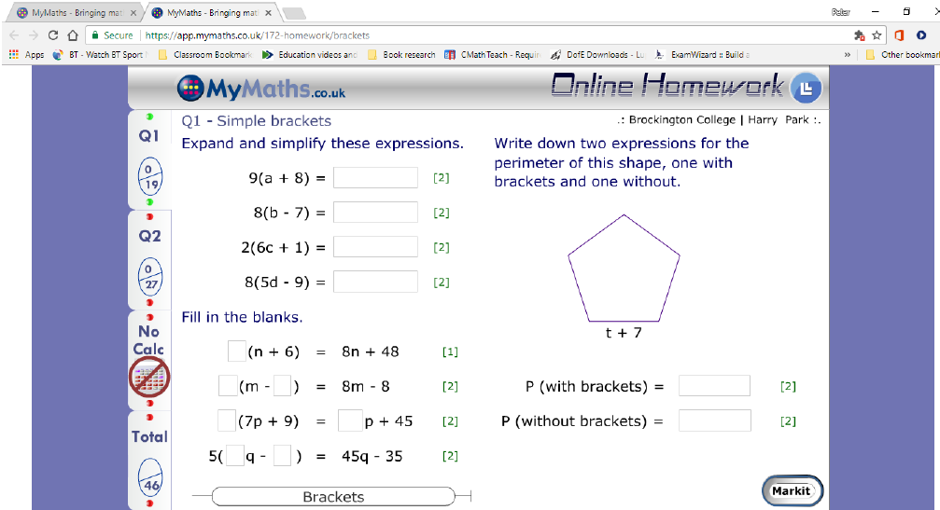

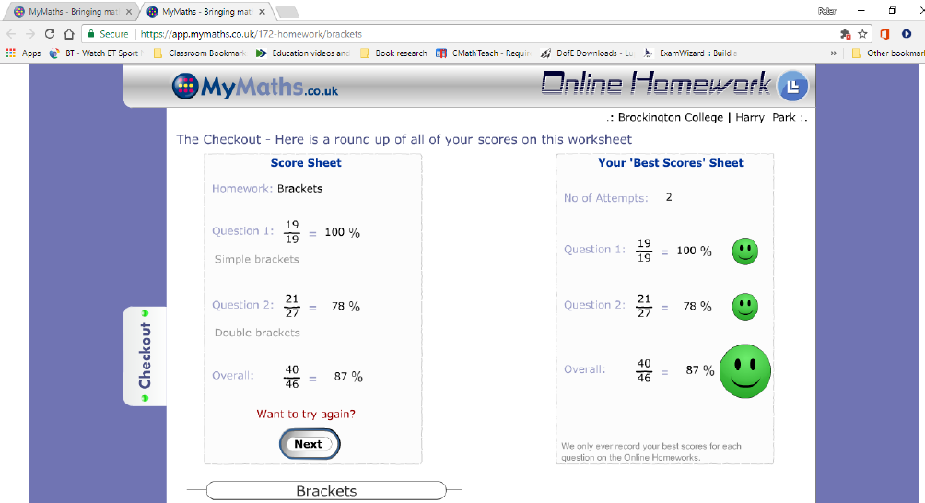

**Mathswatch**

<https://vle.mathswatch.co.uk/vle/>

This is a subscription site. It has videos, practice questions and worksheets. Every topic that is required for GCSE is on the site, accessed via a search facility and explained in a clear way. Past students have successfully used this to improve on topics that they have forgotten or found difficult, particularly when using past papers.

Students have their own login, available from their teacher and the password for all is: WSmwma There is also an app that can be downloaded so students could even use it on the bus home!

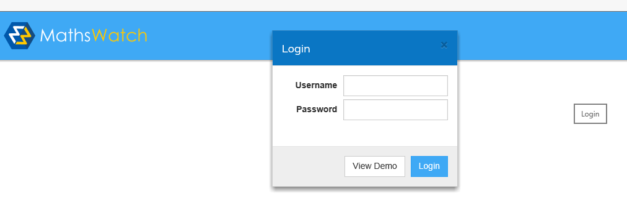

Search for topic using keyword.

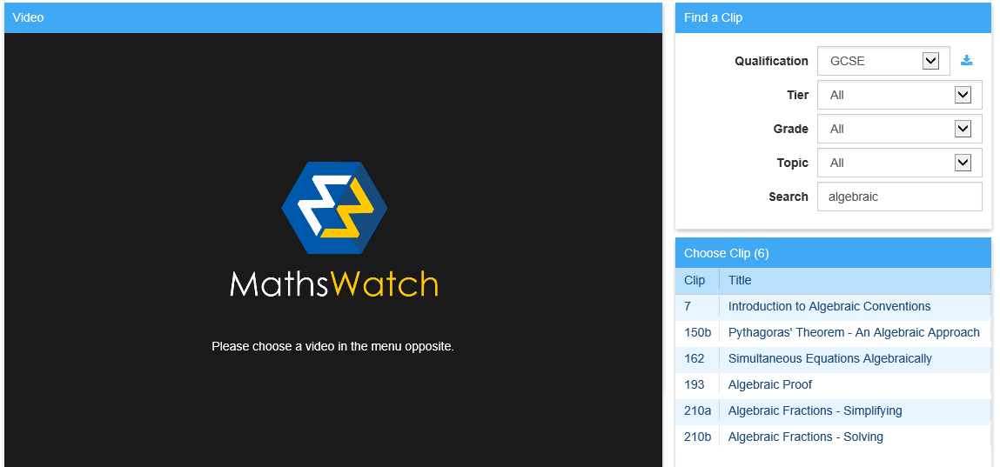

Watch the video (one minute maths or full version) and try the practice questions. Check.

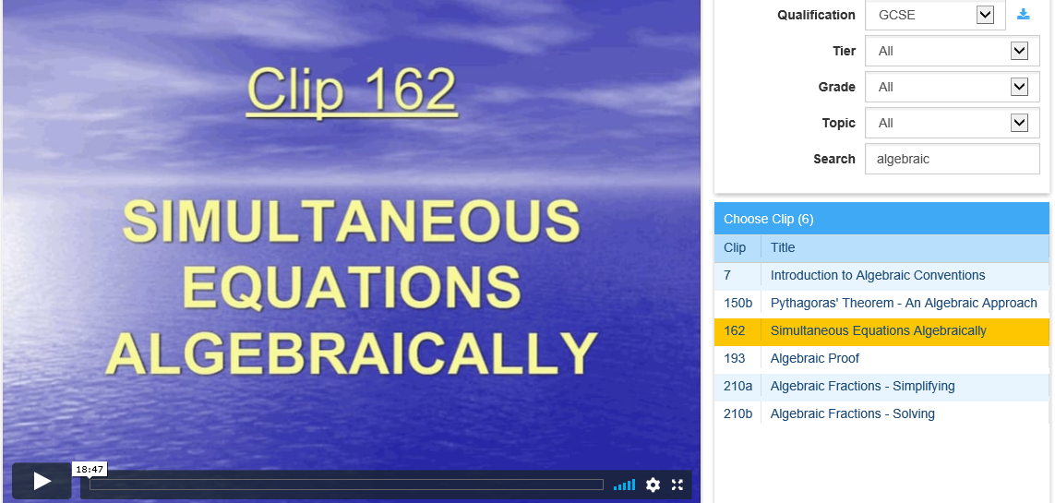

Try the assessment questions.

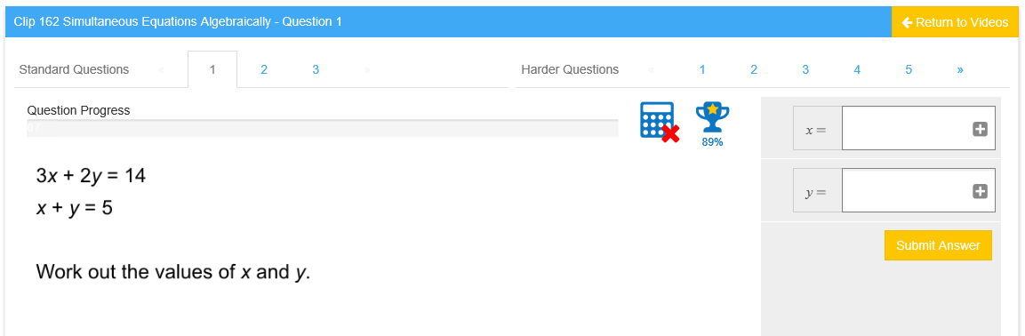

There are also worksheets:

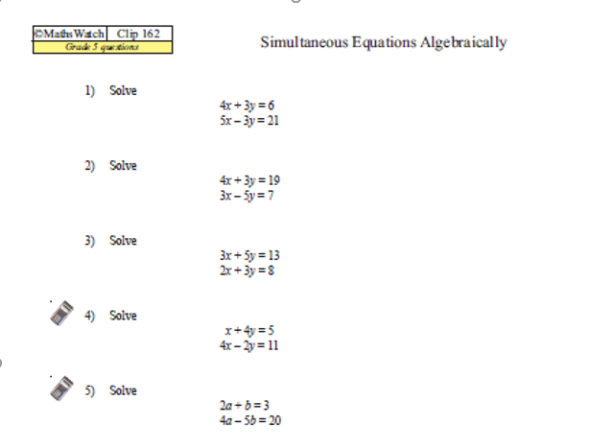

The teacher may also set assignments that will appear on the student’s home page for completion.

**Mathsmadeeasy.co.uk**

This website is free. There are many resources on the site on individual topics as well as papers, formulae and more.

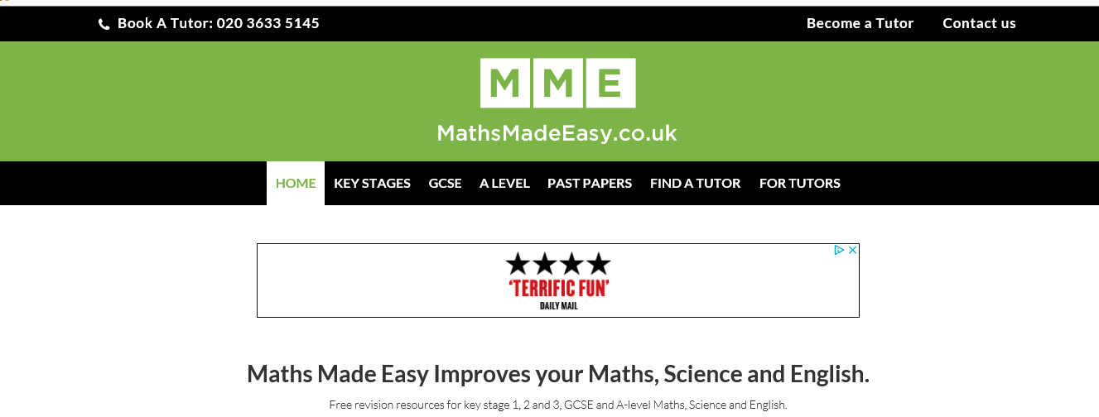

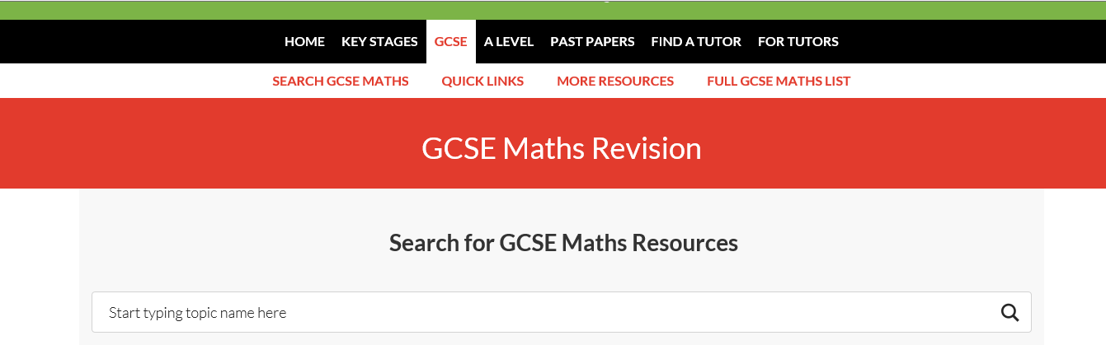

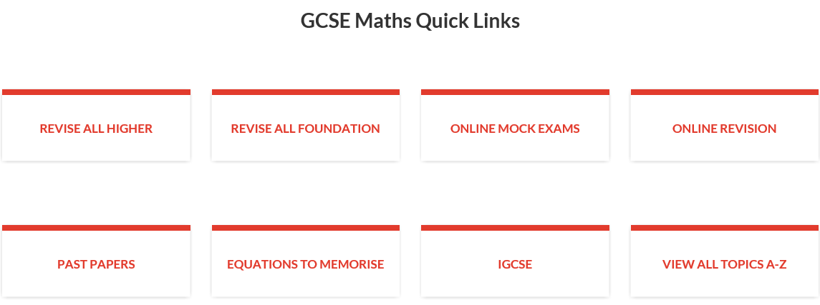

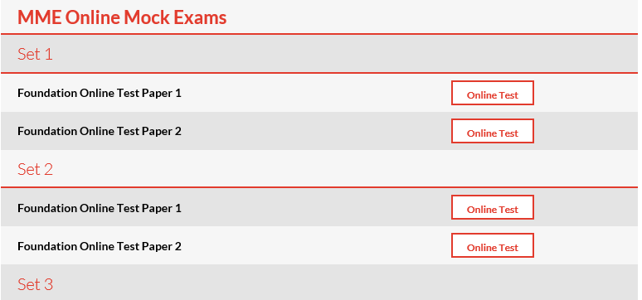

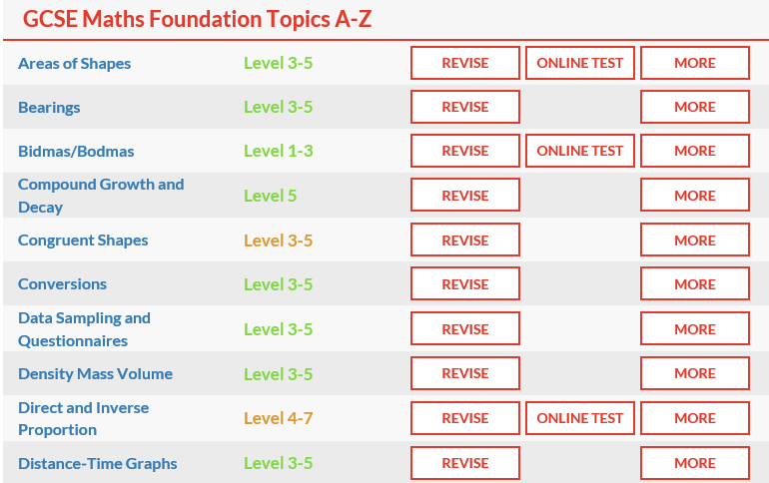

**Corbett Maths**

*Corbett Maths* (https://corbettmaths.com/) – Corbett Maths is a free site that your child can access that provides a great deal of supporting material and question practice.

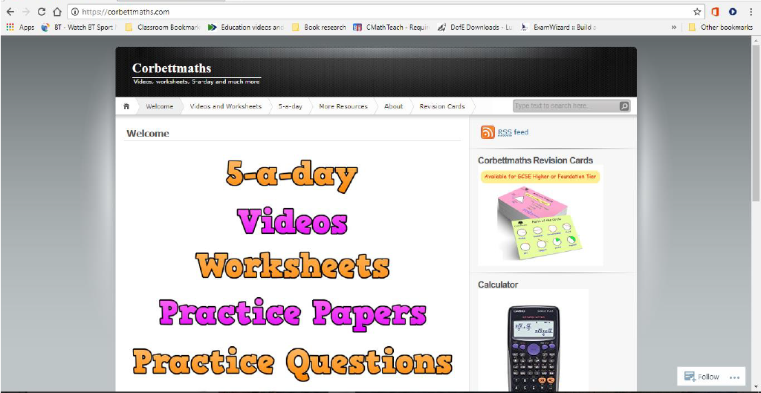

The key area that your child may find useful are the 5-a-day questions alongside the videos. Your child needs to be sure to select the 5-a-day GCSE 9-1 to ensure they are getting suitable questions.

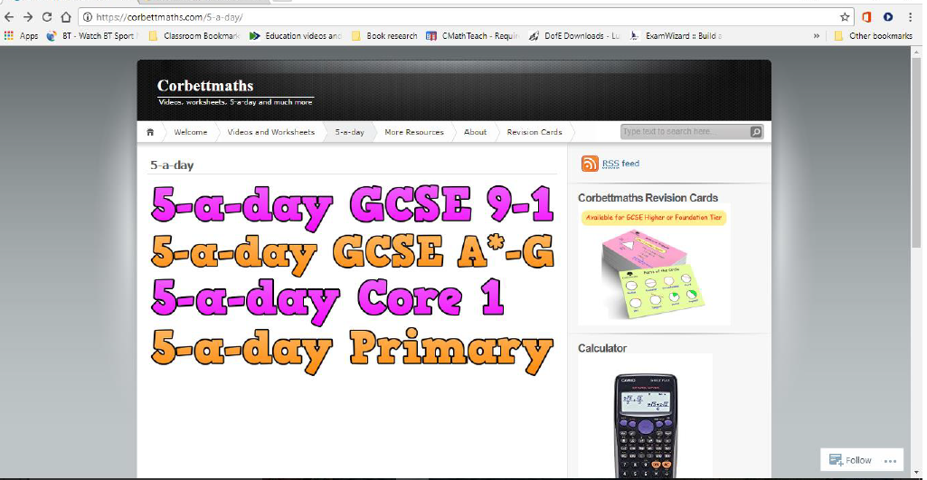

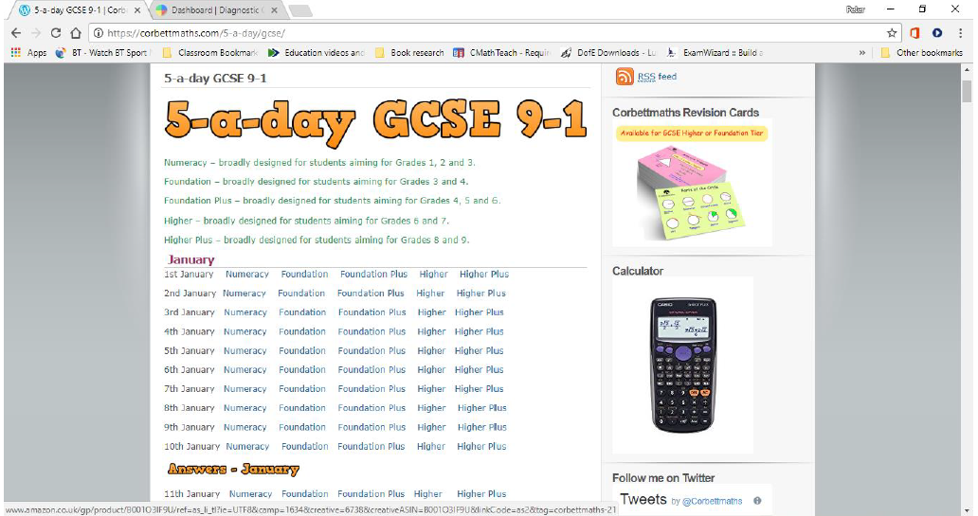

Depending on the tier and set your child is working in, they will find different questions suitable.

The 5-a-day is designed to give students 5 questions for each day of the year to practice different areas of the maths GCSE. They come complete with answers by clicking on the answers link on the page.

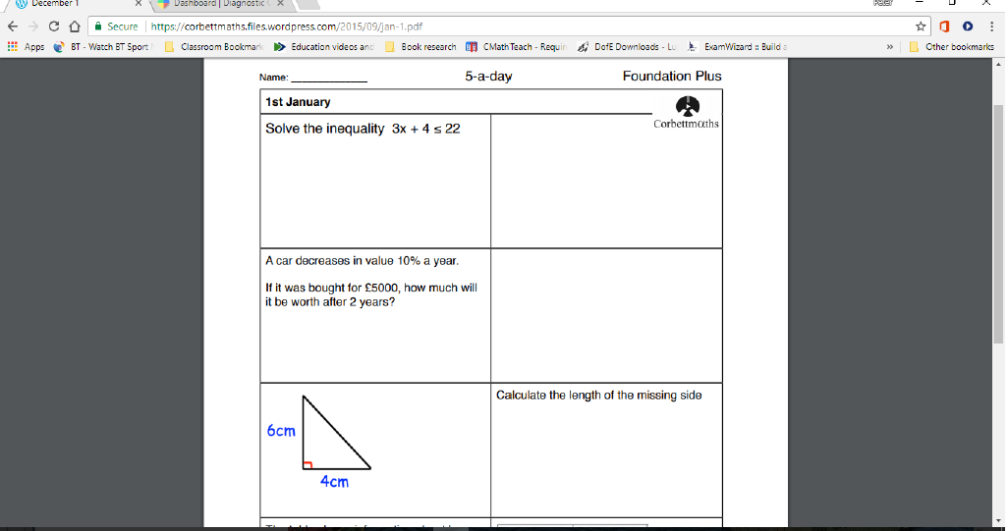

The answers are particularly beneficial as they are model answers that show the calculations required to arrive at the answers rather than just the answer itself.

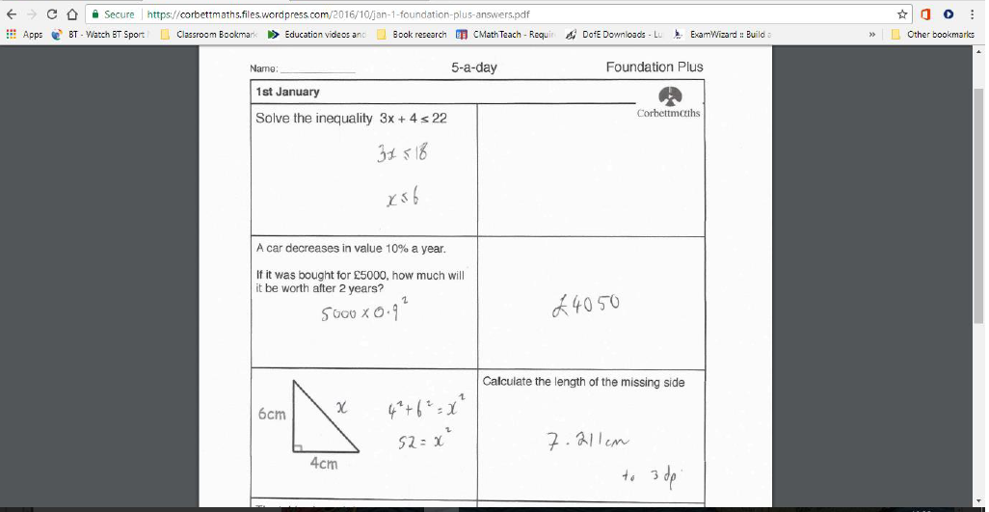

The videos, along with further practice questions and worksheets are designed to support your child with areas they may find difficult. Whilst not as well broken down as the videos from Mathswatch, they can nonetheless be useful.

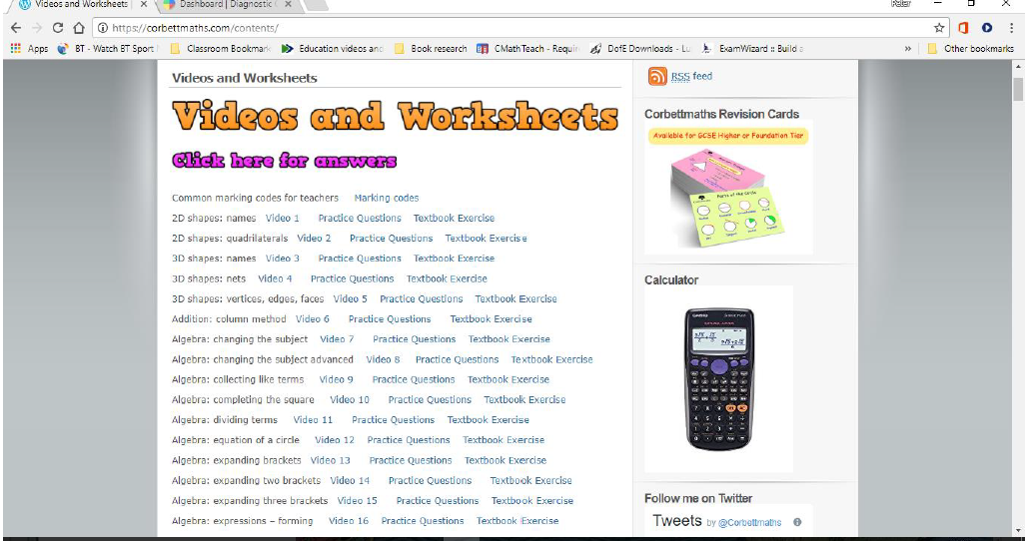

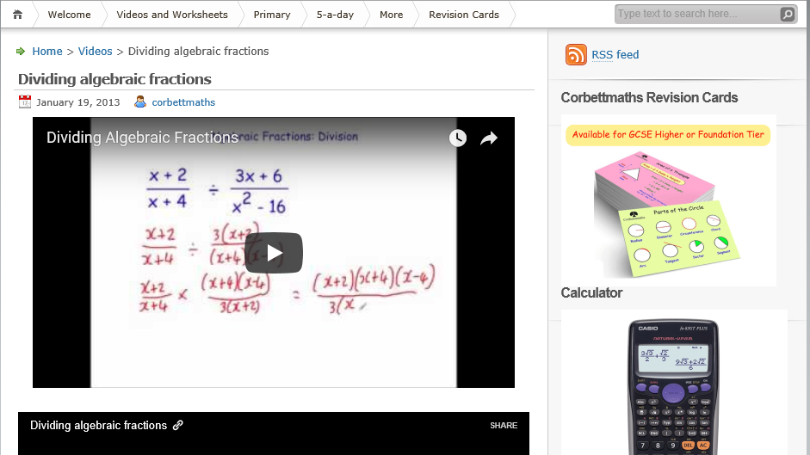

**GCSE Bitesize – Maths**

The site has ‘how to’ and practice questions.

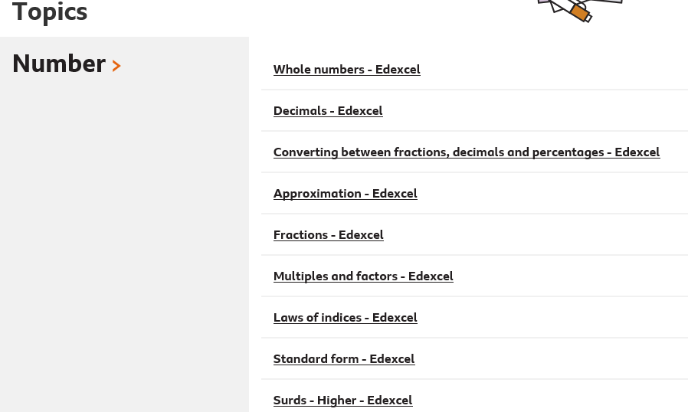

**Other revision resources**

Collins Revision Cards – available from Collins or Amazon

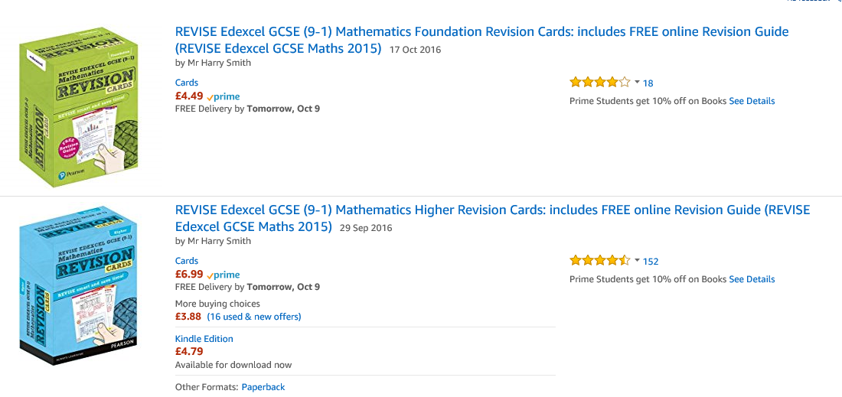

Corbett Maths Revision Cards – from Corbett Maths or Amazon

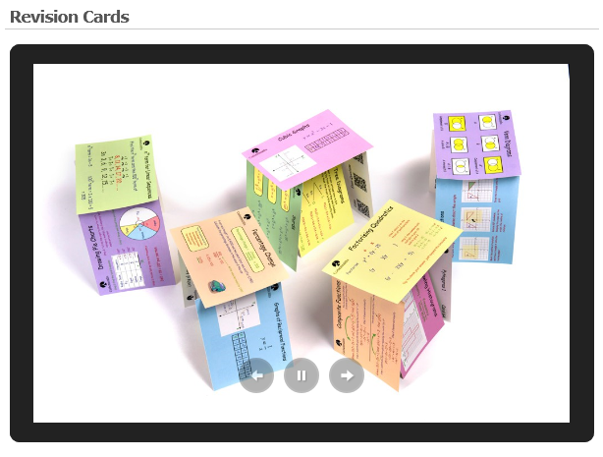



**Collins Revision Books – for sale from school via Parent Pay – at £3.99 each**

**Select only one –Higher (sets 1, 2, 3) or Foundation (sets 4 and 5)**

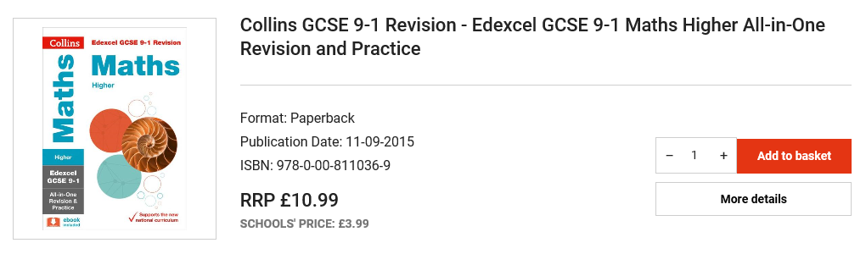

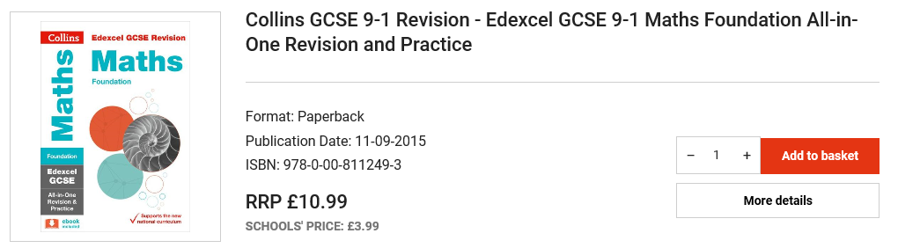

**CGP revision books**

Comprise guides, exam practice, workbooks, answers and practice papers. Available from CGP or Amazon.

